**Front-End UI/UX Mini Project**

**1. Title Page**

* **Project Title**: Travel blog template
* **Submitted By**: 
  + *Team Members-*

*Yoihen Wehengbam (2462175)*

*Nevita Sharon Y (2462121)*

* + *College-E-mail id-*

[*Yoihen.wehengbam@btech.christuniversity.in*](mailto:Yoihen.wehengbam@btech.christuniversity.in)

*Nevita.sharon@btech.christuniversity.in*

* **Course**: *UI/UX Design Fundamentals*
* **Instructor Name**: *Nagaveena.*
* **Institution**: *Christ University*
* **Date of Submission**: *13/08/2025*

**2. Abstract**

The Travel Blog Template project focuses on designing and developing a responsive homepage layout tailored for travel storytelling and content updates. It incorporates mobile-first design principles to ensure optimal viewing across devices. Using CSS Grid and Flexbox, the template organizes content into a clean, accessible structure featuring a header, featured post, recent posts grid, sidebar, and footer. Natural color tones and readable typography enhance the visual appeal and user experience. The project deliverables include HTML, CSS, images, and documentation for easy implementation and reuse. This template provides a scalable, professional foundation for travel bloggers to present their content effectively.

**3. Objectives**

* Build a blog homepage template suitable for storytelling and content updates.
* Apply mobile-first design principles and modular layouts.
* Organize content using cards and sidebars for readability and accessibility.

**4. Scope of the Project**

* Applying **mobile-first design** principles for responsive layouts.
* Using **CSS Grid and Flexbox** for layout structure.
* Using **relative CSS units** (em, %) for scalability.
* Following **natural color themes** (green, blue, brown) and clear, readable fonts.
* Delivering HTML, CSS, images, and documentation (index.html, blog.css, /images/posts/, README.txt).

**5. Tools & Technologies Used**

* **HTML** – Structures the content and layout of the travel blog homepage.
* **CSS** – Styles the page, controls colors, fonts, and spacing.
* **CSS Grid** – Creates responsive, grid-based layouts for posts and sections.
* **Flexbox** – Aligns and distributes elements efficiently within sections.
* **Relative CSS units (em, %)** – Makes the design scalable across different screen sizes.
* **Mobile-first design approach** – Ensures the template works optimally on small screens before adapting to larger ones.

**6. HTML Structure Overview**

* The header, section, main, aside, and footer HTML5 semantic tags are used for structure and SEO clarity.
* **CSS Grid** can be used for arranging the main content and sidebar.
* **Flexbox** is ideal for aligning navigation links and post card elements.

**7. CSS Styling Strategy**

* **Mobile-first, responsive design** – Start styling for small screens and use media queries for tablets and desktops.
* **Layout with CSS Grid & Flexbox** – Use Grid for main content and sidebar arrangement, Flexbox for aligning header, navigation, and card elements.
* **Consistent, scalable units** – Use relative units (em, %) for fonts, padding, and margins to maintain responsiveness.
* **Natural, readable design** – Apply green, blue, and brown tones with clear typography for storytelling.
* **Reusable component classes** – Create modular CSS for cards, buttons, and typography, adding hover and transition effects for interactivity.

**8. Key Features**

* **Responsive, mobile-first design** for optimal viewing on all devices.
* **Structured homepage layout** with header, featured post, recent posts grid, sidebar, and footer.
* **Content organization** using CSS Grid and Flexbox for clean, accessible layouts.
* **Natural color palette** (green, blue, brown) and clear, readable typography for storytelling.
* **Reusable CSS components** for cards, buttons, and typography.
* **Optional interactive elements** like “Back to top” button and hover animations.
* **Scalable design** using relative CSS units for fonts and spacing.
* **Ready-to-use deliverables** including HTML, CSS, images, and documentation.

**9. Challenges Faced & Solutions**

* **Ensuring full responsiveness** across various screen sizes and devices.
* **Balancing aesthetics with readability** while maintaining a natural color palette.
* **Structuring complex layouts** using CSS Grid and Flexbox without layout conflicts.
* **Maintaining consistency** in spacing, typography, and component design.
* **Optimizing images** for faster loading without losing quality.
* **Testing cross-browser compatibility** to ensure uniform display in different browsers.
* **Implementing reusable components** while keeping the CSS file clean and maintainable.

**10. Outcome**

* Achieved a clean, consistent, and visually engaging front-end layout
* All key components function as intended using just HTML and CSS
* Learned about layout responsiveness and UI hierarchy in depth

**11. Future Enhancements**

* **Integrate a CMS** (like WordPress) to manage posts dynamically.
* **Add search and filter features** for easier navigation of blog content.
* **Include dark mode** for better user experience and accessibility.
* **Implement lazy loading** for images to improve performance.
* **Add animations and transitions** for smoother interactions.
* **Integrate social media feeds** beyond Instagram, such as Twitter or YouTube.
* **Enable multilingual support** for a wider audience reach.
* **Add SEO optimization** for better search engine visibility.

**12. Sample Code**

**<section class="featured-post">**

**<img src="images/posts/hero.jpg" alt="Featured Alps" class="featured-image">**

**<div class="featured-content">**

**<h2>Exploring the Alps</h2>**

**<p>Join me on a breathtaking journey through the Swiss Alps. From snowy peaks to cozy villages,**

**discover the hidden gems that make this destination unforgettable.</p>**

**<a href="destinations.html" class="read-more">Read More</a>**

**</div>**

**</section>**

**This section creates a visually striking hero banner for the featured travel post on the homepage.**

**13. Screenshots of Final Output**

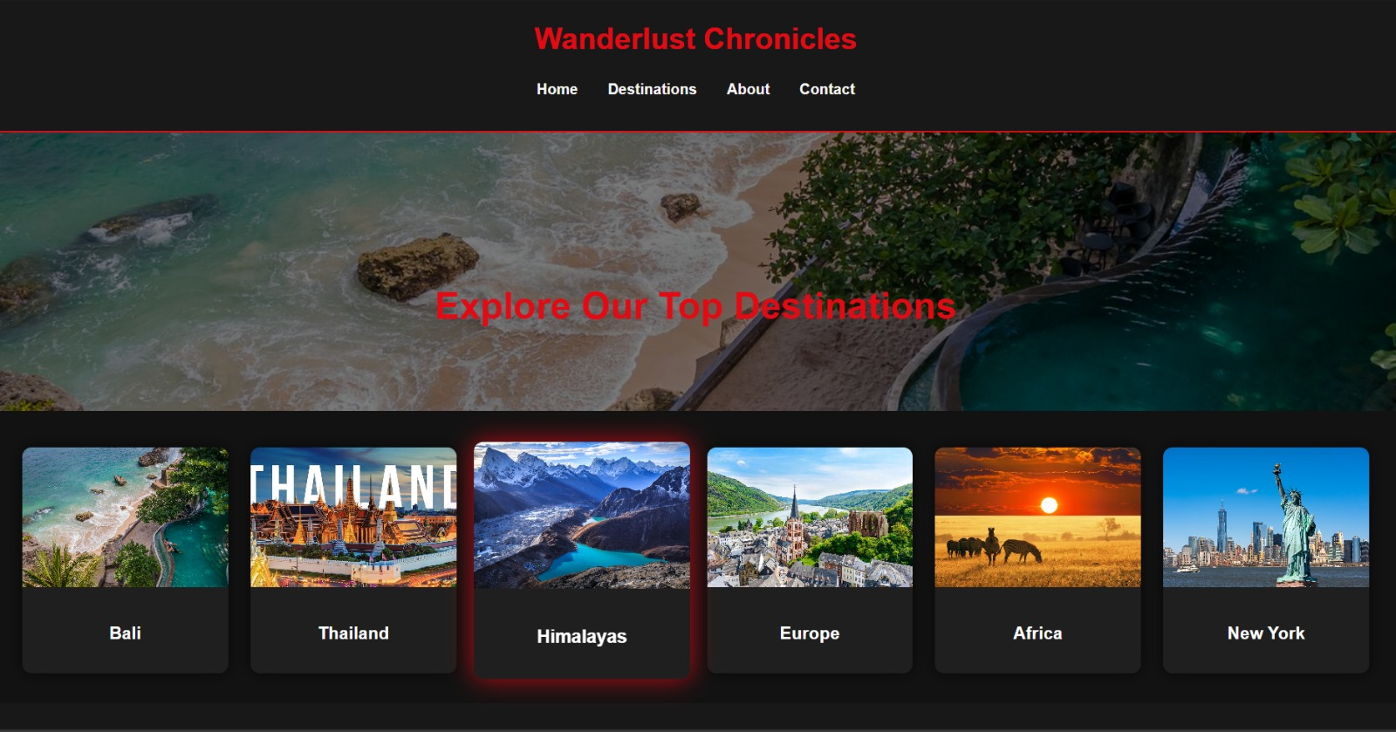

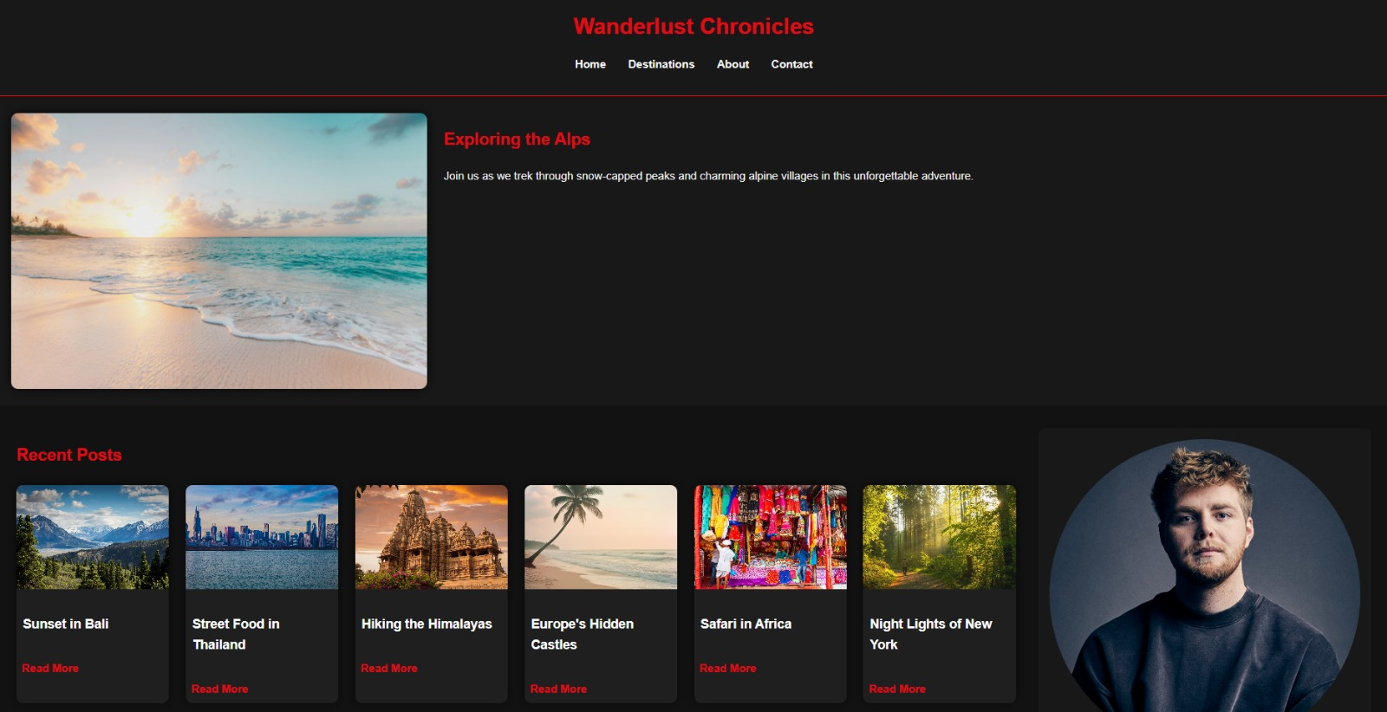

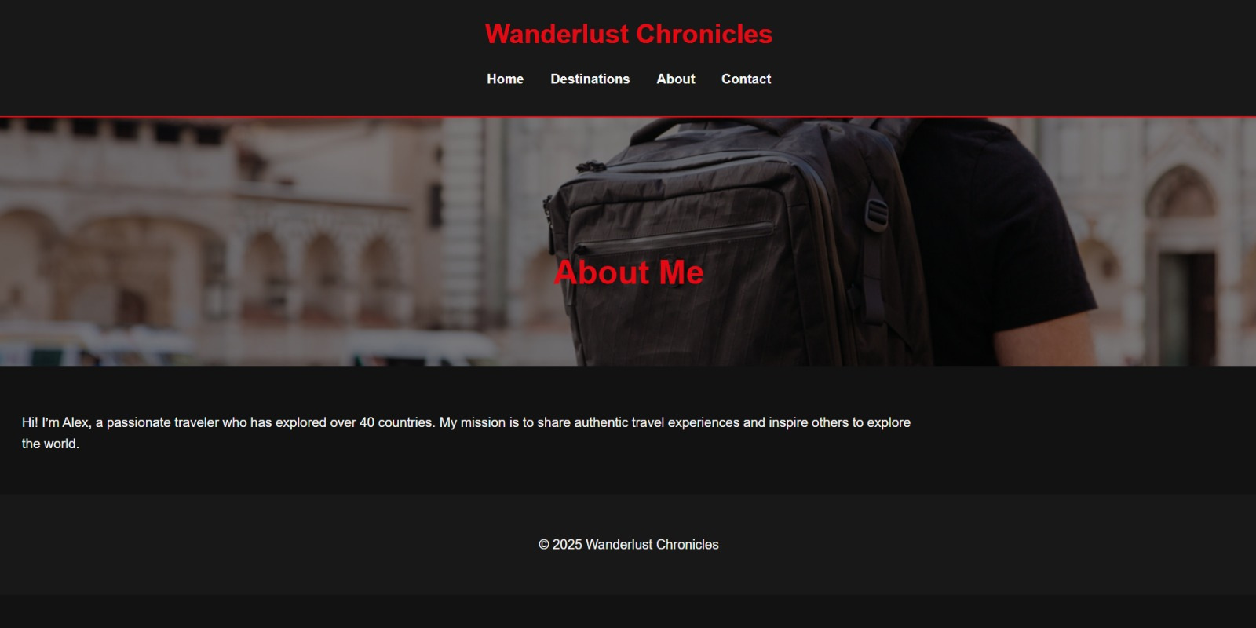

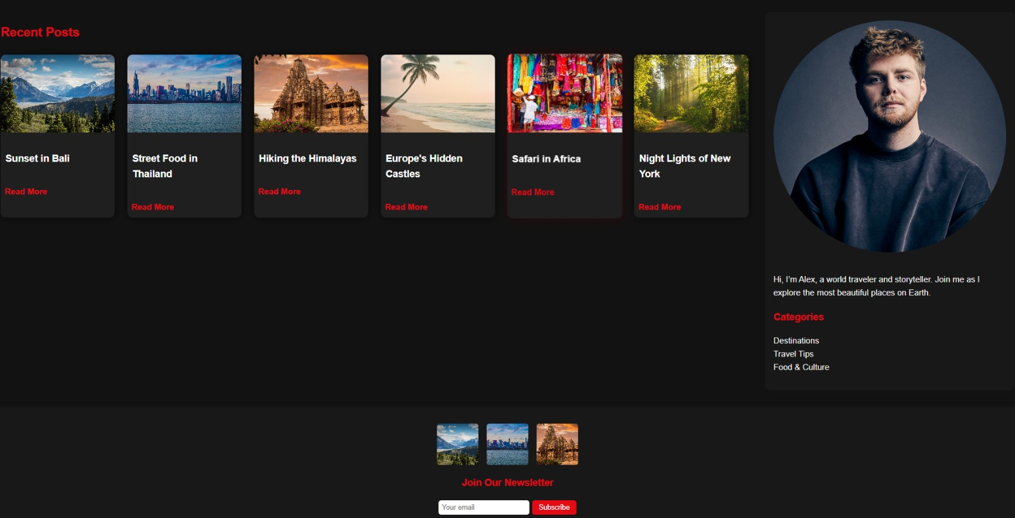

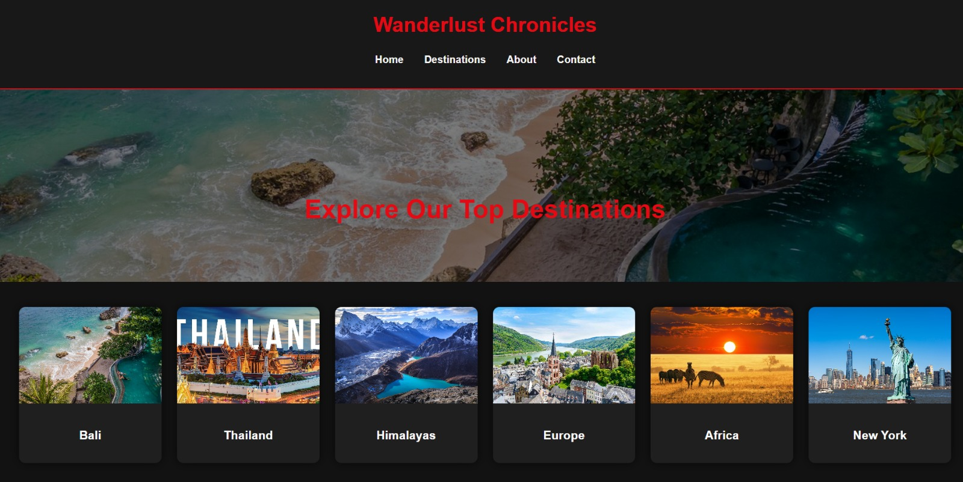



**14. Conclusion**

The Travel Blog Template project successfully delivers a responsive, user-friendly homepage design tailored for storytelling and content sharing in the travel niche. By implementing mobile-first design principles, the template ensures accessibility and seamless viewing across all devices. The use of CSS Grid and Flexbox provides a clean, organized layout that enhances readability and visual appeal. Key sections such as the header, featured post, recent posts grid, sidebar, and footer are structured to present information effectively while maintaining an engaging aesthetic. Natural color schemes and clear typography further support the storytelling purpose of the blog. Optional enhancements like a “Back to top” button and hover animations add interactivity without compromising simplicity. The final deliverables offer a reusable and scalable format, enabling easy updates for future content. Overall, the project meets its objectives by combining design efficiency, clarity, and functionality into a professional travel blog template.

**15. References**

* L&T LMS: https://learn.lntedutech.com/Landing/MyCourse